Social Media analysis of five news agencies

Observation 1

Quite a number of tweets from the news agencies are totally neutral which is a good sign especially since news agencies are supposed to be unbiased.

Observation 2

There are extremes for compound of the last 100 tweets per news agency. To me that would be explained away by the fact that news agencies need to report a range of news thus the wide dispersion. Based on this picture no one firm seems to be highly rated in one area over the other.

Observation 3

The New York Times and Fox News are both negative compound which means they typically report news that is perceived through the Vader analysis as negative. This observation point reinforces the stereo type in common culture about those news organizations. Where CBS is overall positive which again reinforces the common culture belief that CBS news reporting is happier feel good than actual news.

Plots

1. Scatter plot of compound analysis – 3/17/18

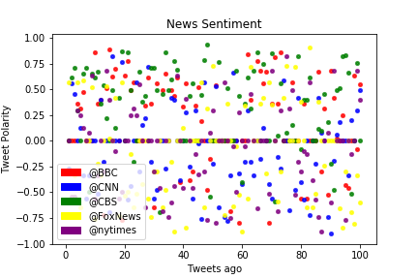

1. Aggregate compound sentiment for news agencies

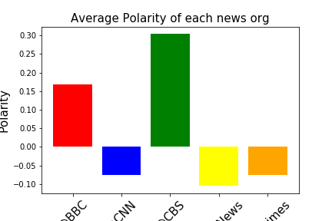

1. Cloudiness v lat

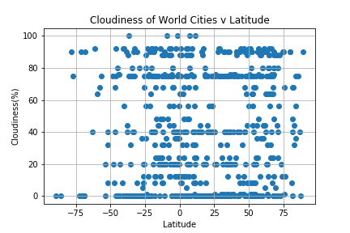

1. Wind speed v lat

